**Policy Pulse Application Documentation**

Dashboard home page provides insights into system health and errors through two main sections: Health Monitoring and Error/Exception Monitoring.

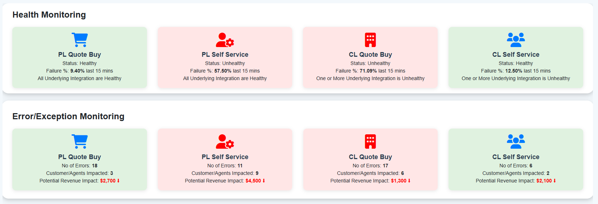

Each section contains clickable tiles, such as PL Quote Buy, PL Self Service, CL Quote Buy, and CL Self Service. Clicking a tile like PL Quote Buy opens a detailed page with information on Personal Lines categories, including Personal Auto, Home Owners, Renters, Vendor Integration, and Client Monitors.

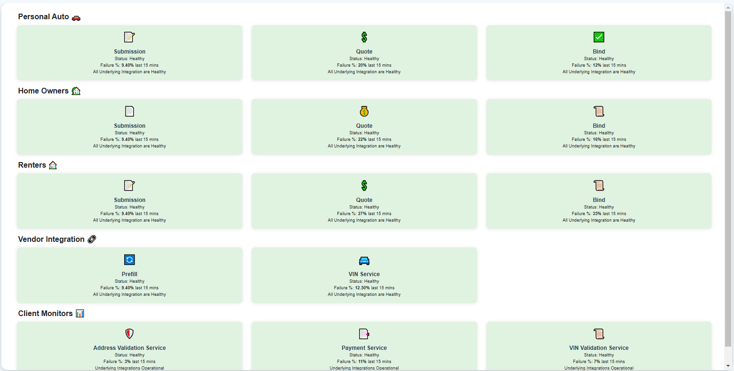

Within Personal Auto, Home Owners, and Renters, there are three key phases: Submission, Quote, and Bind—each represented as clickable tiles.

* Submission Phase: Clicking the Submission tile displays a list of Quotation Numbers along with:
  + Account Name
  + Error Type
  + Page Name
  + Date/Time
* Session ID

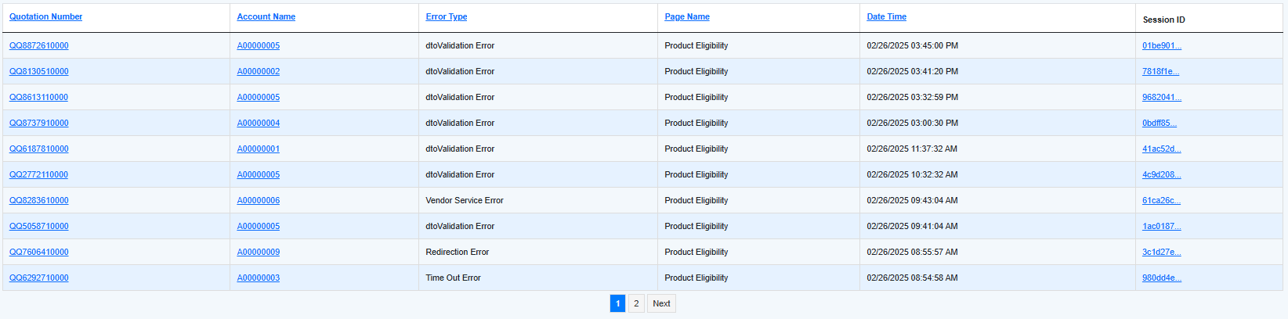

Clicking a Quotation Number hyperlink opens the Quotation Summary, which includes:

* + Agent Name
  + Agency Name
  + Line of Business
  + Date/Time
  + Quote Status
  + Session ID
  + Error Message
  + Error Type
  + Premium Amount
  + Last Page Visited Info
  + Classification

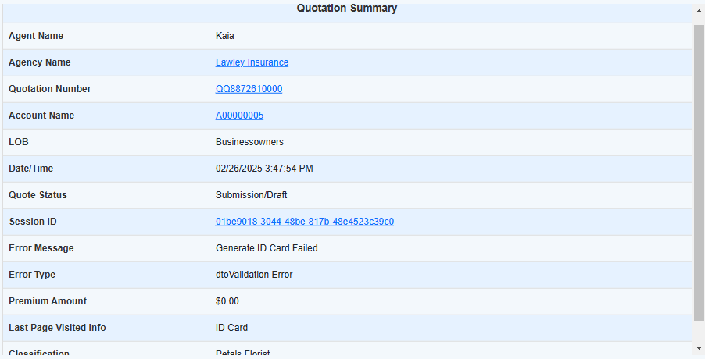

* Quote Phase: Clicking the Quote tile displays Quotation Numbers currently in the Quote phase.
* Bind Phase: Clicking the Bind tile displays Quotation Numbers that have been successfully bound.